**Report on AWS Lambda and EventBridge Rule Implementation**

## **Introduction**

This report outlines the steps taken to implement an AWS Lambda function triggered by an EventBridge rule that runs every minute. The function prints event details and is monitored for execution metrics.

## **Step 1: Creating the AWS Lambda Function**

1. Navigate to the **AWS Lambda** service in the AWS Management Console.
2. Click on **Create function**.
3. Select **Author from scratch**.
4. Provide the function name: myFirstLambda.
5. Choose **Python 3.12** as the runtime.
6. Click **Create function**.

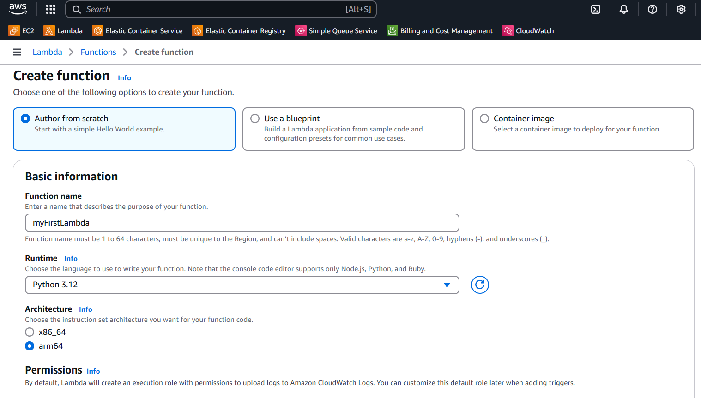

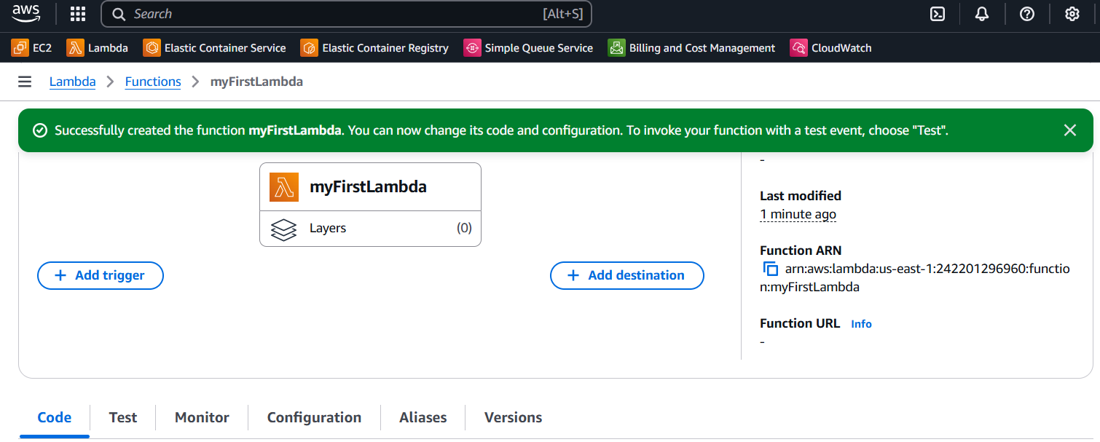

## **Step 2: Writing the Python Code**

1. In the Lambda function editor, replace the default code with the following Python script:

def lambda_handler(event, context):

print(event)

1. Click **Deploy** to save the function.

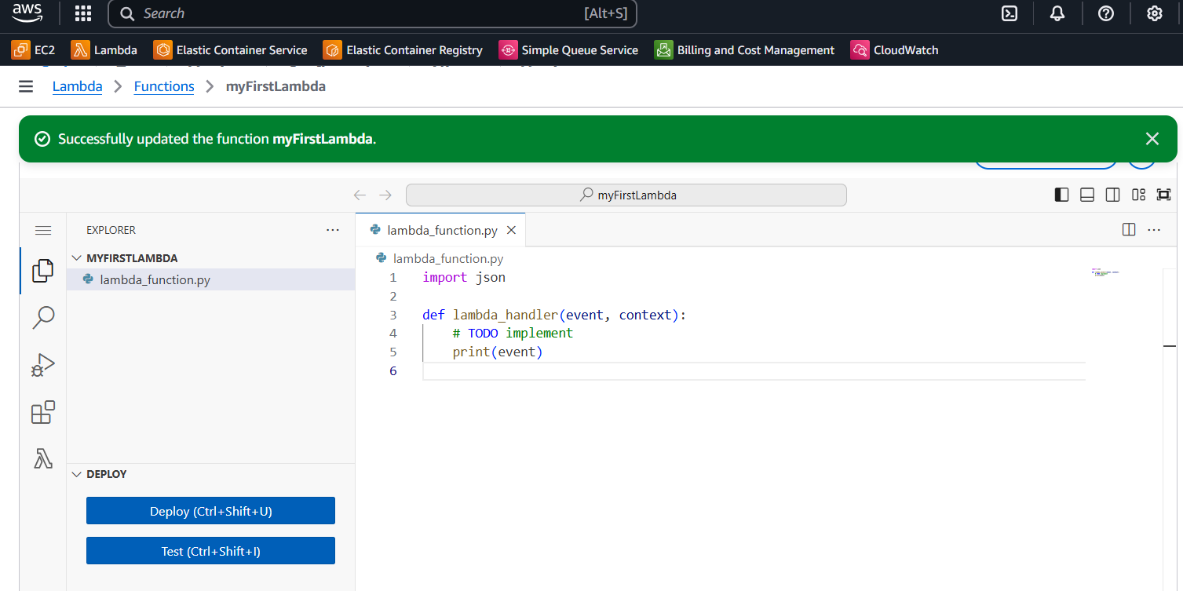

## **Step 3: Creating an EventBridge Rule**

1. Navigate to the **Amazon EventBridge** service.
2. Click on **Rules** in the sidebar.
3. Click **Create rule**.
4. Enter the rule name: LambdaRule1.
5. Choose **Schedule** as the rule type.
6. In the **Schedule pattern**, enter the cron expression: * * * * ? * (runs every minute).

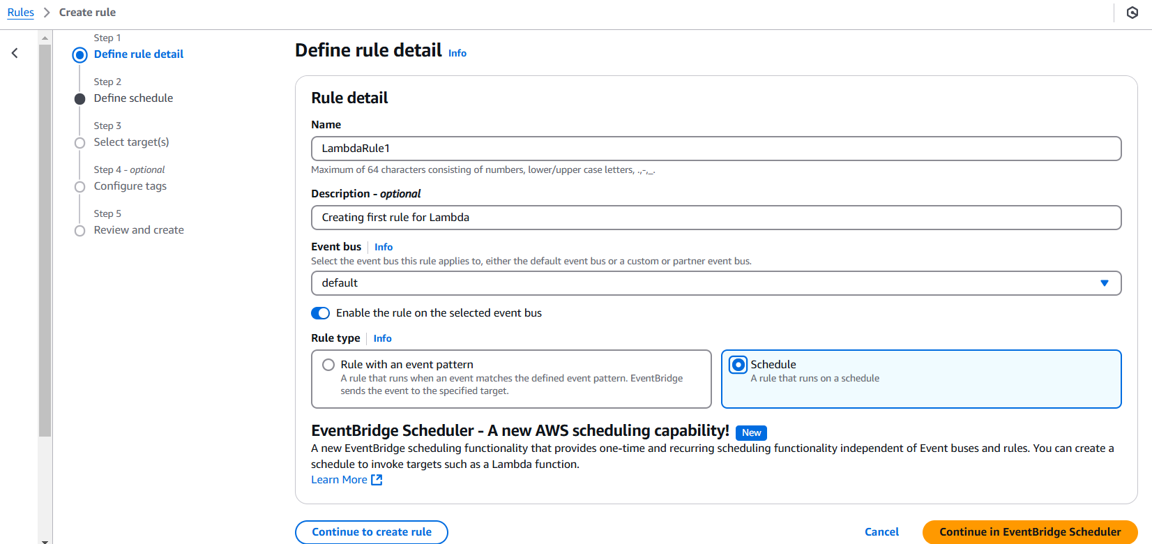

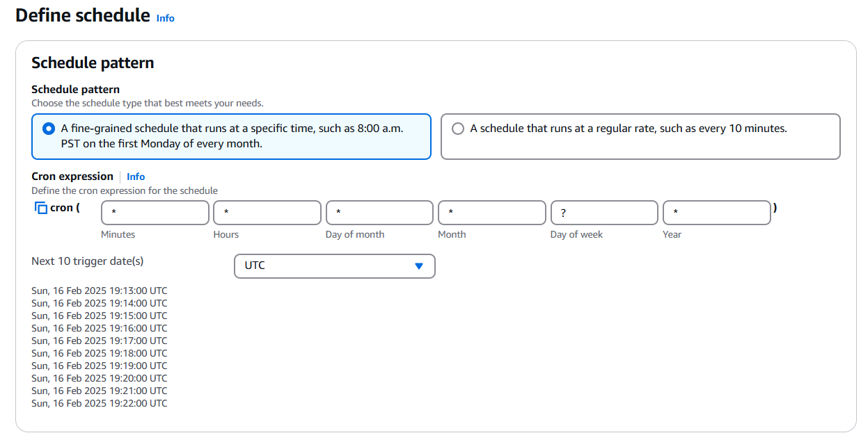

## **Step 4: Adding the Lambda Function as the Target**

1. In the **Target** section, select **AWS Lambda function**.
2. Choose myFirstLambda from the dropdown.
3. Click **Create rule**.

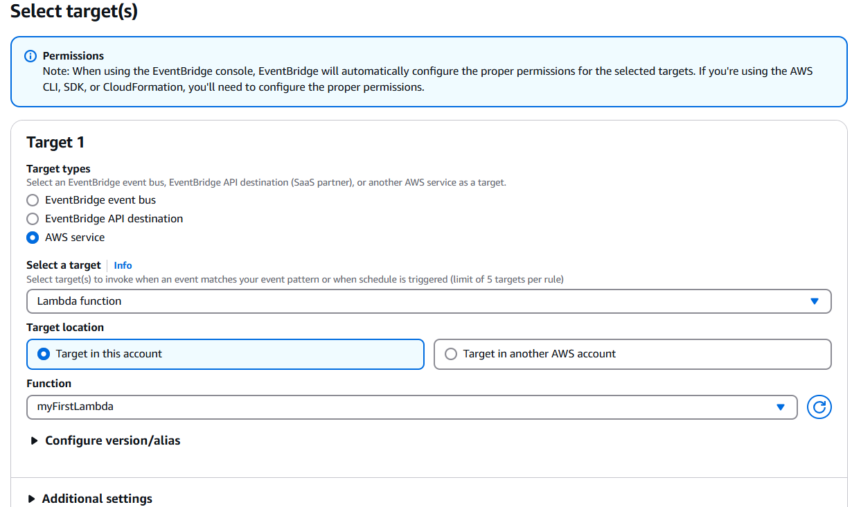

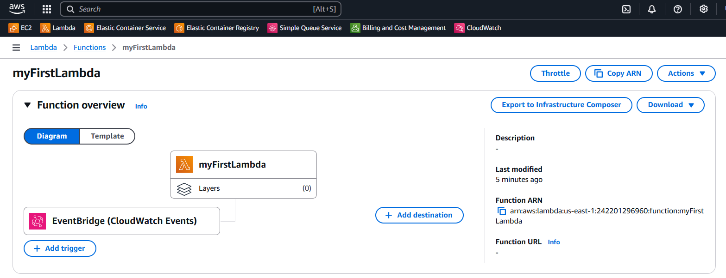

## **Step 5: Monitoring the Execution**

1. Navigate to **AWS CloudWatch**.
2. Open the **Logs** section and find myFirstLambda.
3. Check the logs for event execution details.
4. Open **Metrics** and verify the invocation count.

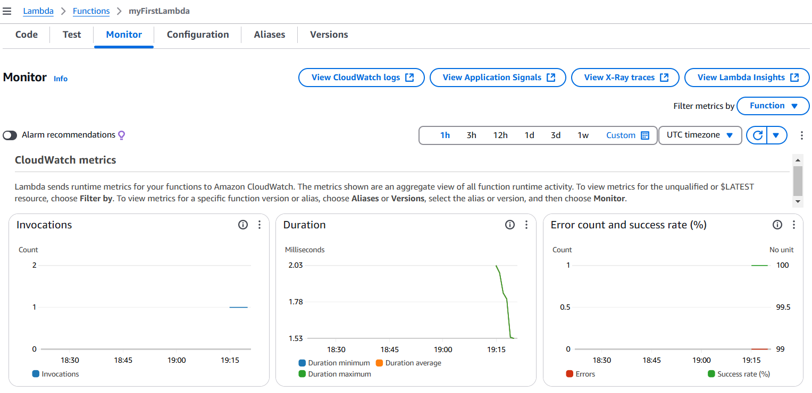

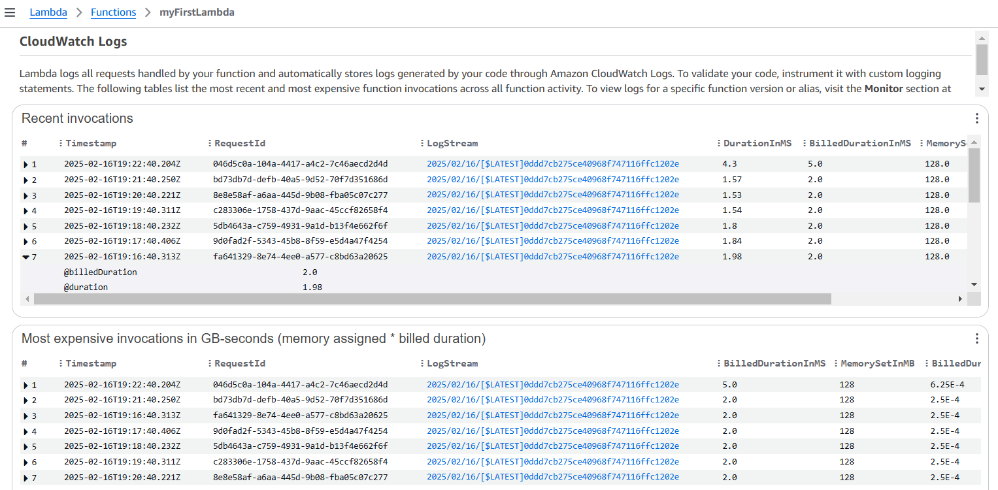

## **Conclusion**

The AWS Lambda function myFirstLambda was successfully created and scheduled using EventBridge Rule LambdaRule1. The function was verified to run every minute by monitoring CloudWatch logs and execution metrics.